MECH 415 Assignment #3

Question #1

a) Develop an Array class to dynamically store a matrix using a dynamic 1D array. The member variables are as follows:

N - the number of rows
M - the number of columns
*p - a pointer to a dynamic 1D array of doubles

Note a matrix (2D array) can be stored in a 1D array one row at a time in the following format:

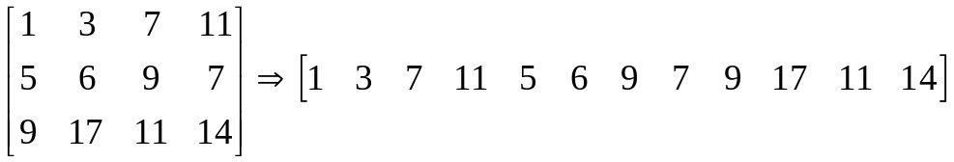

In order to do this you should develop a mathematical expression that relates the matrix indices (i,j) to the index of the 1D array (k). For the example above, if (i,j) =(2,3) [value = 9] then k=6 (assuming the 1D array starts at zero).

Write the following member functions. Perform error checking and print out error messages when appropriate.

b) Array(n,m) – A constructor that initializes the matrix to the identity matrix if the matrix is square and zero otherwise. n is the number of rows and m is the number of columns. Note the function should also initialize p, the pointer to the dynamic 1D array.

c) ~Array() – A destructor that should free resources used by the class.

d) Array(file_name) - A constructor that initializes the member variables from a file of unknown size. Each row of the matrix is stored on a separate line in the file with spaces between the columns. The name of the file is stored in the string variable file_name. This function should determine N and M from the file. Note that the function fin.getline(s1,n1) can be used to read and count the number of lines in a file, where s1 is an array of characters with a size of n1 (just pick a large value for n1). Furthermore, a file can be read again after it is closed.

e) max() – A function that returns the maximum value of the matrix elements.

f) e(i,j) - An access function that returns a reference to the (i,j) element of the matrix. Boundary checking should also be performed to make sure (i,j) is not out of range.

g) Modify the Array(n,m) constructor to have default arguments of n=3 and m=3.

h) Write a function add(A,B,C) that computes C = A + B, where A, B, and C are Array objects. Hint: add is not a member function, make sure the destructor doesn’t get called too many times.

i) Illustrate the Array class using an appropriate main() function.

